**Q1. Software is a collection of programs, data, and instructions that tell a computer how to operate and perform specific tasks.**

1. **Software engineering is a branch of computer science that involves designing, developing, testing, and maintaining software application.**

**Q2.** 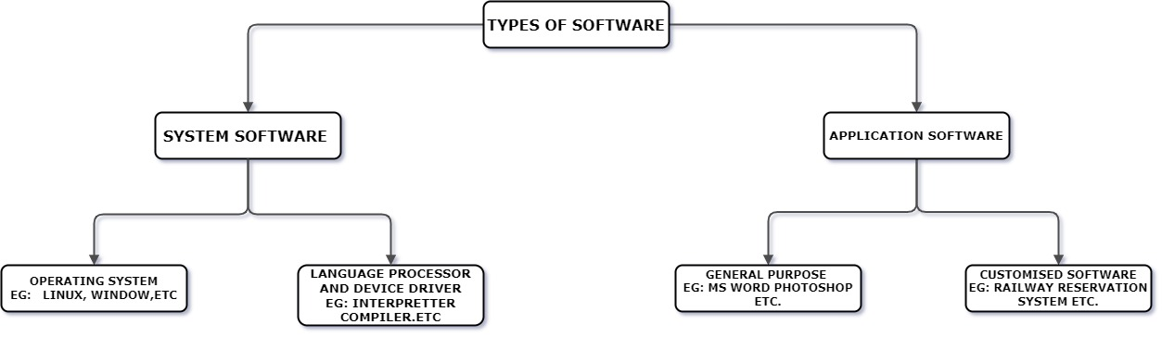

**Q3. SDLC stands for Software Development Life Cycle, which is a systematic process for planning, writing, modifying, and maintaining software.**

**(1)**

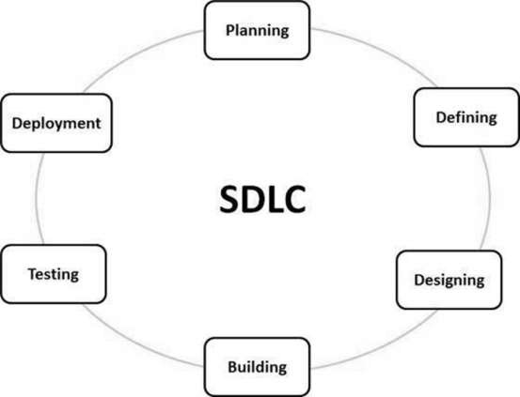

**Q4. A data flow diagram (DFD) is a visual representation of how information moves through a system or process.  DFDs are used in many industries, including software engineering, business management, and database development**.

**(1).**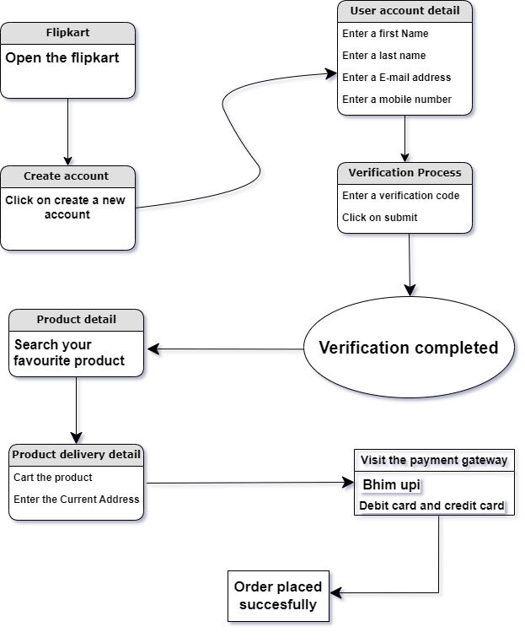

**Q4. A flowchart is a diagram that shows the steps, sequences, and decisions of a workflow or process.**

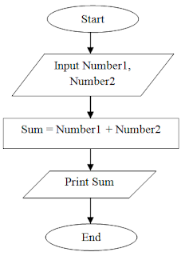

**Q5. A use case diagram is a visual representation of the interactions between a system's elements, and the users within that system.**

